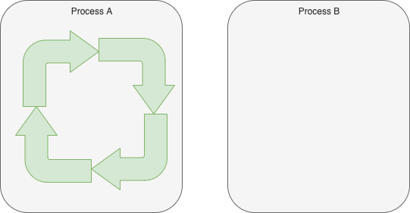
Fig. <$n:figure:NaturalLoop> Natural Loop

Looping naturally fits the notions of non-distributed programming.

